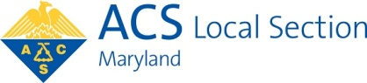

Minutes of Executive Meeting of
Maryland Section of the American Chemical Society
In person in Key G59, Morgan State University/Virtual Meeting on Zoom
Chair Beatrice Salazar, presiding
April 16, 2025

Present: Eric Cotton, Ayse Gul Yavuz Cular, Kelly Elkins, Louise Hellwig, Jan Kolakowski, Rachael Matthews, Sara Narayan, Jiangnan Peng, Beatrice Salazar, Sunita Thyagarajan, Robert von Tersch Stephanie Watson, Sarah Zimmerman

Beatrice called the meeting to order at 6:05 p.m.

The Minutes of the last meeting, February 12, 2025, were approved with correction of the spelling of Ayse’s name on page 2.

Jan reported that our money market funds took some losses. Our Fidelity Contra Fund has a balance of $144,178.10, a loss of about 13%. Our Nicholas Fund has a balance of $168,675.83, a loss of about 11%.

Eric presented the current Treasurer’s Report, attached to these Minutes, with the correction that our current Total Balance Less Liabilities is $1412.73. He requested that members submit requests for reimbursement accompanied by invoices and receipts rather than scans of credit card bills.

Jan went over his Council Report, attached to these Minutes, from the national ACS meeting.

Beatrice reported on the Maryland Chemist Award event. Sara reported on the Women Chemists Committee event of March 12.

Louise reported that a student applied for a travel grant to the national ACS meeting in Washington, DC in August. Since we have already used our budgeted travel grant funds for 2025, approving this grant will have to be put up for a vote.

Beatrice reported that the Maryland Chemistry Olympiad went very well. George Owens of CCBC prepped the area for the practical lab exam, and Camilo Rojas brought in the refreshments for after the exam.

Ayse reported that award certificates have been sent out to 50-60 year ACS members. Stephanie will explore the possibility of a Luncheon perhaps in June for these awardees.

This year’s Mid Atlantic Regional Meeting (MARM) will be held in New Jersey at the end of May. We received a request to sponsor this meeting at the Bronze level with $500. We would

be recognized on all the official papers at the event. This sponsorship will be sent out for a vote by the E-board.

We also received a request to help sponsor a particular research symposium, geared to early career chemists, at the national ACS meeting in Washington in August. Robert will enquire with the organizers further about their current engagement in the Maryland Section Younger Chemists Committee.

Rigoberto Hernandez has offered to speak to our Section at a meeting in early fall, either in person or via Zoom. He is promoting a Remsen Landmark to be erected in 2026 during the celebration of the 150th anniversary of the ACS.

Sara reported there were about 77 attendees at the very successful Student Awards Luncheon on Sunday April 27 at Notre Dame.

Beatrice requested reimbursement for $118.12 used for the Maryland Chemist Award event. There was some debate about money budgeted for one year but not used, being used in the next year.

Louise reported on our Maryland Section version of Project SEED, in which high school students receive $2000 stipends for summer research. We have four applicants. Since this program is in our 2025 budget, those four students can each receive a stipend.

Our By-Laws state that various decisions and events must be recorded in the Chesapeake Chemist, a monthly newsletter which is currently not being published. It is very hard to change the By-Laws, so it was decided to simply label a page on the Section website as The Chesapeake Chemist and record the decisions and events there.

There was discussion about the Section’s social media, such as the website, Constant Contact, etc. It was not clear whether we pay a set annual amount for Constant Contact, or whether we pay according to how many flyers are sent. Ayse asked that a calendar linked to Google calendars be set up. There was further discussion about our Google mail account.

The meeting was adjourned at 8:10 p.m.
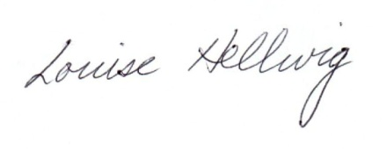
Respectfully submitted,
Louise Hellwig, Secretary Two Reports on following pages

