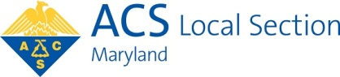

Minutes of Executive Meeting of
Maryland Section of the American Chemical Society
on Zoom
Chair Beatrice Salazar, presiding
November 19, 2025

Present: Chris Avanessian, Christine Chin Choy, Eric Cotton, Ayse Gul Yavuz-Cular, Larissa D’Souza, Kelly Elkins, Louise Hellwig, Jan Kolakowski, Ioan Marginean, Jillian Malbrough, Sara Narayan, Jiangnan Peng, Beatrice Salazar, Sunita Thyagarajan, Robert von Tersch, Sarah Zimmerman

Beatrice called the meeting to order at 6:06p.m.

The Minutes of the September 24 meeting were approved.

Beatrice reported that the Remsen meeting, led by Dana Ferraris, on Nov. 17 went very well.
Dr. Bettina V. Lotsch was the awardee.

Tamara Henderson is webmaster of the Section website, succeeding Nicole Carbonaro.

There was discussion about a possible December Social in lieu of a formal meeting. The date, time, and location remain to be determined, as well as whether the Section or individual attendees would pay.

Rose Pesce-Rodriguez is Volunteer of the Month for October in light of all her outreach events at local libraries.

Larissa was invited to attend the ACS Leadership Institute in Atlanta in January, seeing as how Larissa is Chair Elect.

Christine, of Frederick Community College, and Ioan, of University of Baltimore, newly elected Alternate Councilors, introduced themselves. Chris, of Johns Hopkins University, newly elected Member at Large, introduced himself.

Eric presented the current Treasurer’s Report, as well as the 2026 Budget, which was passed. Both documents are attached to these Minutes. Eric pointed out we have about $55,745 income, about $44,115 budgeted, and about $8,000 outstanding liabilities. There was some debate about how to handle these liabilities (uncashed checks).

Money is set aside for three members (Ayse, Larissa, and Sunita) to attend the Leadership Institute in Atlanta in January.

Louise reported that the Braude Award dinner Oct. 22 went well with about 30 attendees enjoying dinner, then a presentation by the awardee, Dr. Thomas Lectka.

At the Section’s September meeting, ACS Chair-Elect Rigoberto Hernandez was the featured speaker; the event was held at CCBC. There was much discussion about a grant for this meeting from LSAC, the Local Section Activities Committee of the ACS, which Beatrice declined. She said she was not informed of the details of the grant request and did not want to sign something she didn’t know about. After consultation with the Chair of LSAC, we can get a $3500 grant from LSAC if we submit a proposal by the end of January 2026 for another Section event.

Jan reported that our money market funds took some losses. Our Fidelity Contra Fund has a balance of $178,220.15, a loss of about 3.1% since Sept. Our Nicholas Fund has a balance of $185,366.80, a loss of about 1.4% since Sept.

There was interest in having a social event, perhaps at a brewery/winery/distillery tour.

Sunita proposed giving out two Maryland Section Teaching Awards to university faculty in our area. Budgeting two times $500 for these awards was approved.

Sunita also proposed a university level Poster Session for undergraduates. $1000 was budgeted for this event.

The Annual Report to ACS must be submitted by Feb. 15, 2026.

There was discussion about our Constant Contact account. Perhaps it might be cheaper to consolidate our announcements into fewer “mailings”.

We have to submit a list of our Section officers to the national ACS by December 1. Any officer who has moved out of state must be removed from our list. Then we will update the website.

The catering for the Maryland Chemist Award meeting for 2025 was $400 above the $2900 that was budgeted. Payment of this overrun was approved.

Kelly announced that the national ACS Nominations and Elections Committee needs input in the form of nominations. Also Kelly is starting a Forensic Chemistry subdivision; please promote membership in this subdivision to your colleagues.
Beatrice reported that the national ACS is paying for the Ira Remsen landmark to be installed at Johns Hopkins University. They are also contributing $2000 for a Remsen reception in October of 2026.

Ayse showed a video of the National Chemistry Week event she spearheaded at CCBC.

The meeting was adjourned at 8:00 p.m.
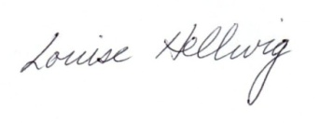
Respectfully submitted,
Louise Hellwig, Secretary

Two Reports follow:

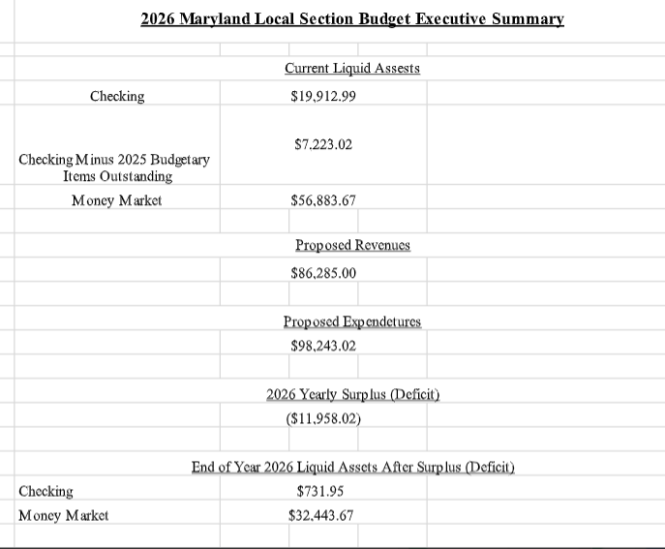

ACS Section Treasurer’s Report – September 2025
M&T Checking Balance as of September 2025 $26,949.00

CREDITS

10/29/2025 Grant From National (Unknown – Beatrice) $195.00
11/06/2025 Deposit from National for Counselor Rebate $8,000.00
11/12/2025 Deposit from National for Local Section Dues $2,607.31
Total Credits: $10,802.31

DEBITS
Converted Liabilities

7/16/2025 Check #2877 to Alex Lohse for MD Project SEED $1,000.00
7/16/2025 Check #2875 to Safora Noor for MD Project SEED $1,000.00
8/18/2025 Check #2888 to Ella D&#39;Ambrosio for MD Project SEED $1,000.00
8/18/2025 Check #2887 to Alex Lohse for MD Project SEED $1,000.00
8/18/2025 Check #2885 to Safora Noor for MD Project SEED $1,000.00
9/15/2025 Check #2894 to Kelly Elkins for Councilor Travel $636.41
9/23/2025 Check #2895 to Beatrice Salazar for ACS Showcase Event $200.00
9/23/2025 Check #2896 to PJ Mitchel for Hernandez Membership Door

Prize $197.00
New Transactions

10/6/2025 Check# 2897 Braude Award Framing Reimb to Louise Helwig $227.69
10/6/2025 Check# 2898 to Caroline B. ACS Memb Student Hernandez

Event $49.00
10/13/2025 Check #2899 to Ayse Cular for Mole Day Reimbursement $248.68
10/20/2025 Check #2901 to Ayce Cular for Mole Day Reimbursement $274.93
10/27/2025 Check #2903 Reimbursement to EC for Election Runner $103.59
11/3/2025 Check # 2904 to Sandy Olsen for Remsen Plaque $610.00

11/11/2025 Check# 1968 to Study Baltimore Catering for Braude Dinner 1,968.00
Total Debits: $9,515.30
Current Checking Account Balance as of November 2025 $28,236.01

Pending Transactions (Liabilities):

New Liabilities

10/22/2025 Check# 2902 to JHU Chem for Braude Award for Lecthe $4,000.00
11/17/2025 Check #2906 to Sandy Olsen for MD Chemist Plaque $585.00

Old Liabilities

04/10/2022 Check # 2648 for 2022 MD Section Mini Grant Morgan State $1,500.00
04/10/2022 Check # 2651 for 2022 MD Section Mini Grant NMDU $1,500.00
06/30/2022 Check # 2672 for CCEW Poetry Contest $50.00
06/30/2022 Check # 2697 for CCEW Poetry Contest $50.00
03/20/2024 Check #2784 Nicole Godwin Mileage for WCC Event $138.02
10/31/2024 Check #2830 Emely Gomez Final Project SEED Payment $500.00

Total Outstanding Liabilities: $8,323.02

TOTAL BALANCE LESS LIABILITIES: $19,912.99

M&T Money Market Account: Balance as of 02/11/2025 is: $56,883.67

Please Note these changes:

1) Money Market Transfer is now INCLUDED as a revenue so that we can plan the amount of the transfer. This means that we are no longer showing as much of a deficit.

2) The liabilities that we canceled and returned are listed as both a debit and a credit, so they zero themselves out. However, the $1500 to Morgan and the $1500 to NDMD are now listed as additional line items of expense since we are planning to rewrite those checks.

