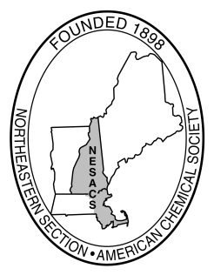Northeastern Section
American Chemical Society, Inc.
The Gustavus John Esselen Award Committee

11 Thaxter Street Phone (617) 620-8315
Hingham, MA 02043 Email JPiperGrady@gmail.com

September 3, 2024

TO: ACS Section and Division Chairs, Editors of Newsletters, Industry Leaders, Research Directors, and Chairs of Academic Departments

FROM: Dr. Penny Beuning, 2025 Chair of the Esselen Award Committee

SUBJECT: Request for Nominations for the 2025 Esselen Award for Chemistry in the Public Interest

The Northeastern Section of the American Chemical Society is pleased to invite nominations of worthy candidates for the Gustavus John Esselen Award for Chemistry in the Public Interest. This award recognizes a chemist for outstanding achievement in scientific and technical work that contributes to the public well-being. The award consists of a $5000 prize and a medal of recognition. The presentation takes place at an award ceremony in April at Harvard University, followed by a formal address by the awardee. The tentative date for this ceremony is April 10, 2025.

The award was established in 1987 to honor the memory of Gustavus John Esselen, a distinguished scientist, entrepreneur and member of the Northeastern Section. The first awardees were F. Sherwood Rowland and Mario J. Molina, who subsequently received the Nobel Prize. Since then, several Esselen Award recipients have also been Nobel laureates and many have been recipients of the most prestigious awards in their various fields.

Please note: any field of chemistry or affiliation is appropriate for nomination. The primary consideration of the committee is that the scientific work has been an important contribution to the public well-being and that the work’s significant value to society has become apparent within the last five years or so.

This letter is to seek nominations of colleagues whose work meets the criteria and purpose of the award. The enclosed brochure provides more detail on the nature of the award, a list of previous awardees as well as the criteria and procedure for nominations. Additional information is available at http://www.nesacs.org/awards_esselen.html.

The deadline for nominations is October 11, 2024.

We would appreciate you posting the award notice and circulating the information as appropriate. Thank you in advance for your interest.

